Review II

- Determine whether the expression is a tautology:

- – (P & - P)
(-PvP)=t
- P v ( P & - P )
(P&-P)=c
- – [ P v ( P & Q) ] v P
(-PvP)=t
- [ ( P → Q ) → P ] → P
(-PvP)=t
- P → [ Q → ( P & Q ) ]
(-PvP)=t

- Determine whether the expression is a contradiction:

- – ( P v – P )
(-P&P)=c
- [ P & ( Q v P ) ] & - P
((P&Q)vP)&-P = (-P&Q)
- – [ - ( P → Q ) → P (])
--(P-->Q)=(-PvQ)

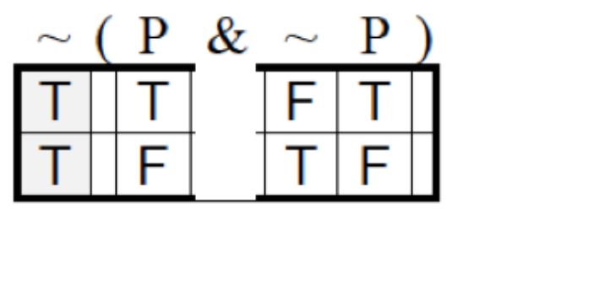
(-PvP): t

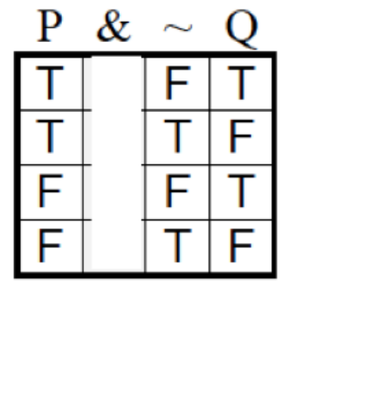
(P&-Q):FTFF

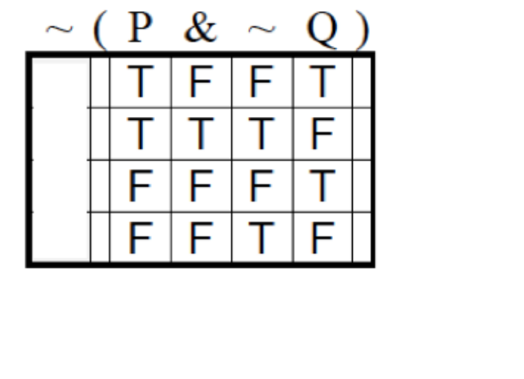
(-PvQ): TFTT
Use the truth tree method

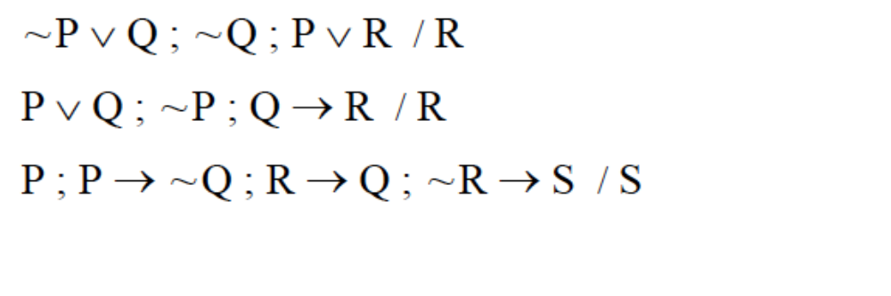
-R
P-------------R
-P------------Q
-Q, Valid

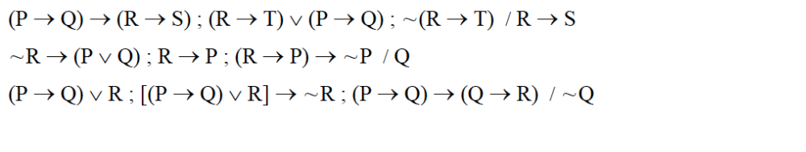
(R&-S)
R,-S
R,-T
R,-T------------(-P)------------Q
P,-Q------------(-R)------------S ccc
T?, NOT V

